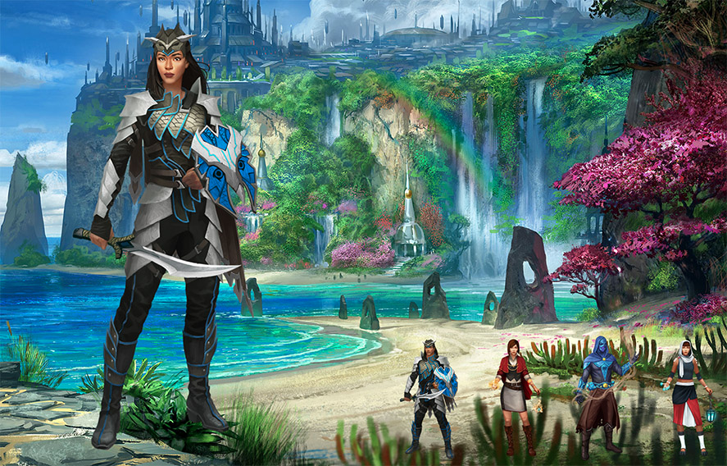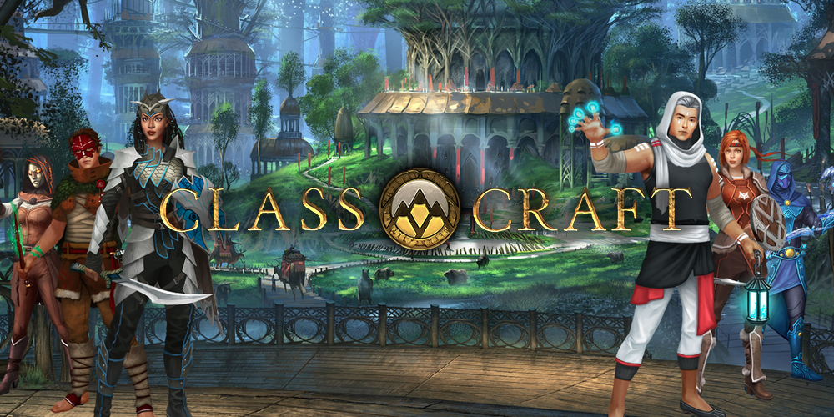

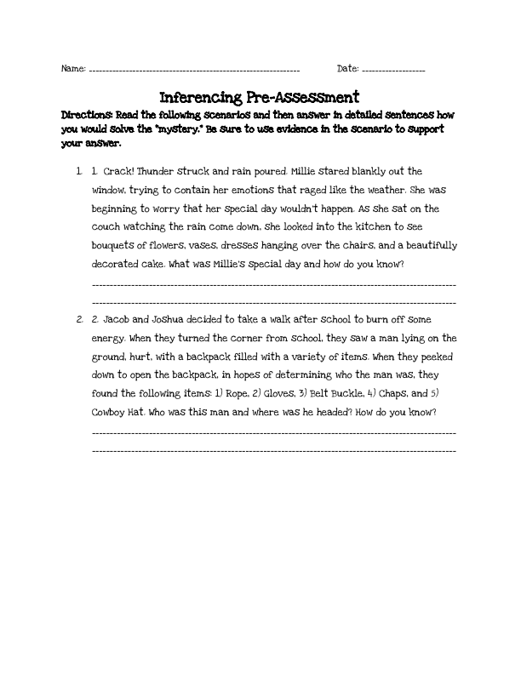 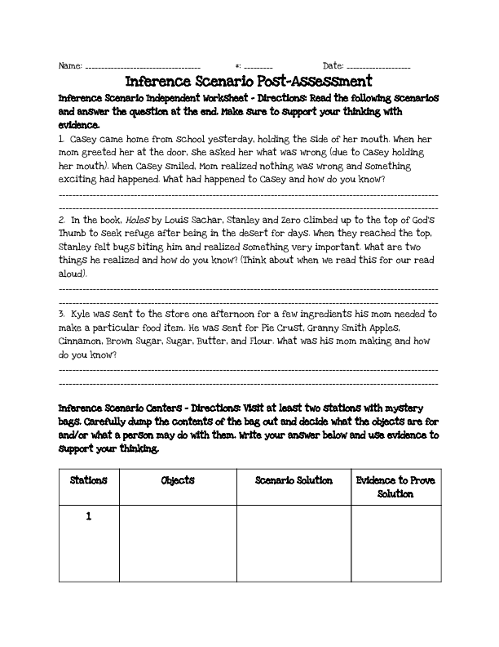 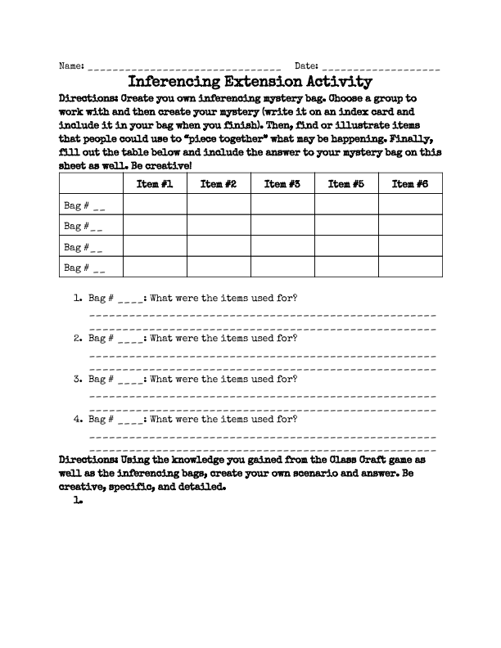

Pre- and Post-Assessments and Extension Activity for Students

Where Do I Find the Lesson Plan?

<http://editor.wix.com/html/editor/web/renderer/edit/2e141c1c-0e35-4b9c-83c5-423c86ad94fc?metaSiteId=6cb81092-a283-4b0b-971b-f94bbf293dc6&editorSessionId=92E42AB0-53DC-4DEC-B5AA-099E5D78D63D>

Where Do I Find Supplemental Materials?

[http://team5digitalcitizen.wix.com/conqueryourquest - !supplemental-materials/c1233](http://team5digitalcitizen.wix.com/conqueryourquest#!supplemental-materials/c1233)

**Class Craft Webpage Handout**

(Click on the links below to take you to where you need to go!)

+

+